**AWS re/Start Challenge Lab - Using AWS CloudFormation to create an AWS VPC and Amazon EC2 instance**

**Lab Overview:**

This lab is an environment for creating an Amazon VPC and Amazon EC2 instance (and other supporting elements) using an AWS CloudFormation template. The goal of this lab is to create a CloudFormation template with the following components:

* **An Amazon Virtual Private Cloud.**
* **An internet gateway attached to the VPC.**
* **Security groups for accessing the VPC configured to allow SSH from anywhere.**
* **A private subnet within the VPC.**
* **An Amazon EC2 instance (a T3.micro) within the private subnet.**

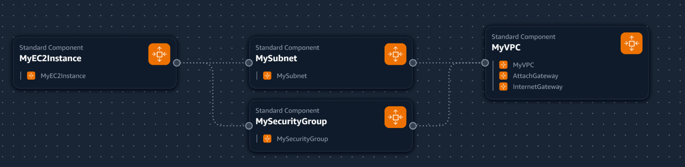

**Step 1:**

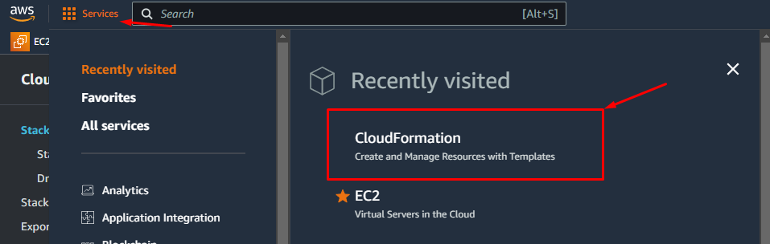

**Step 2:**

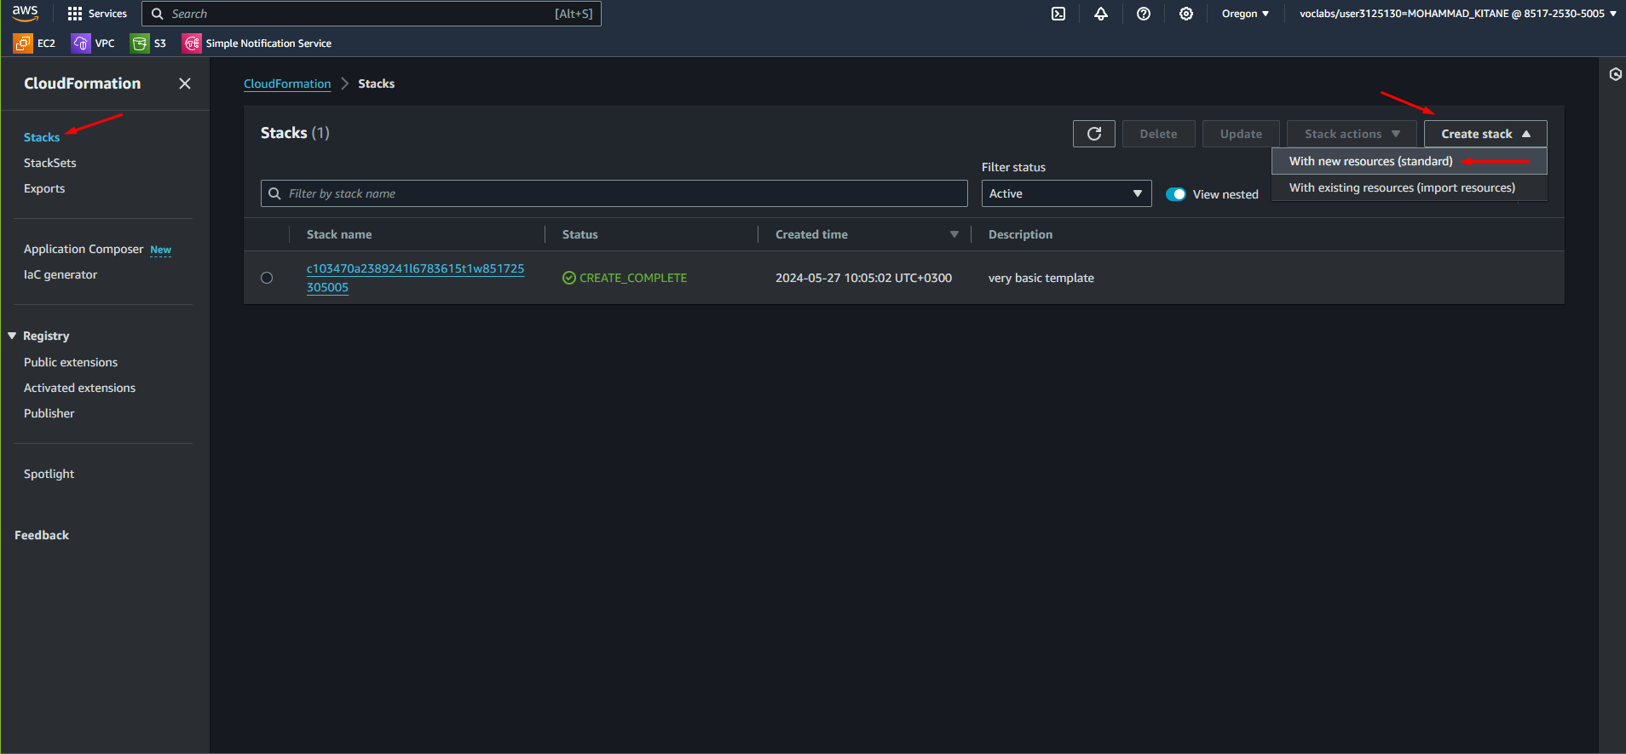

**Step 3:**

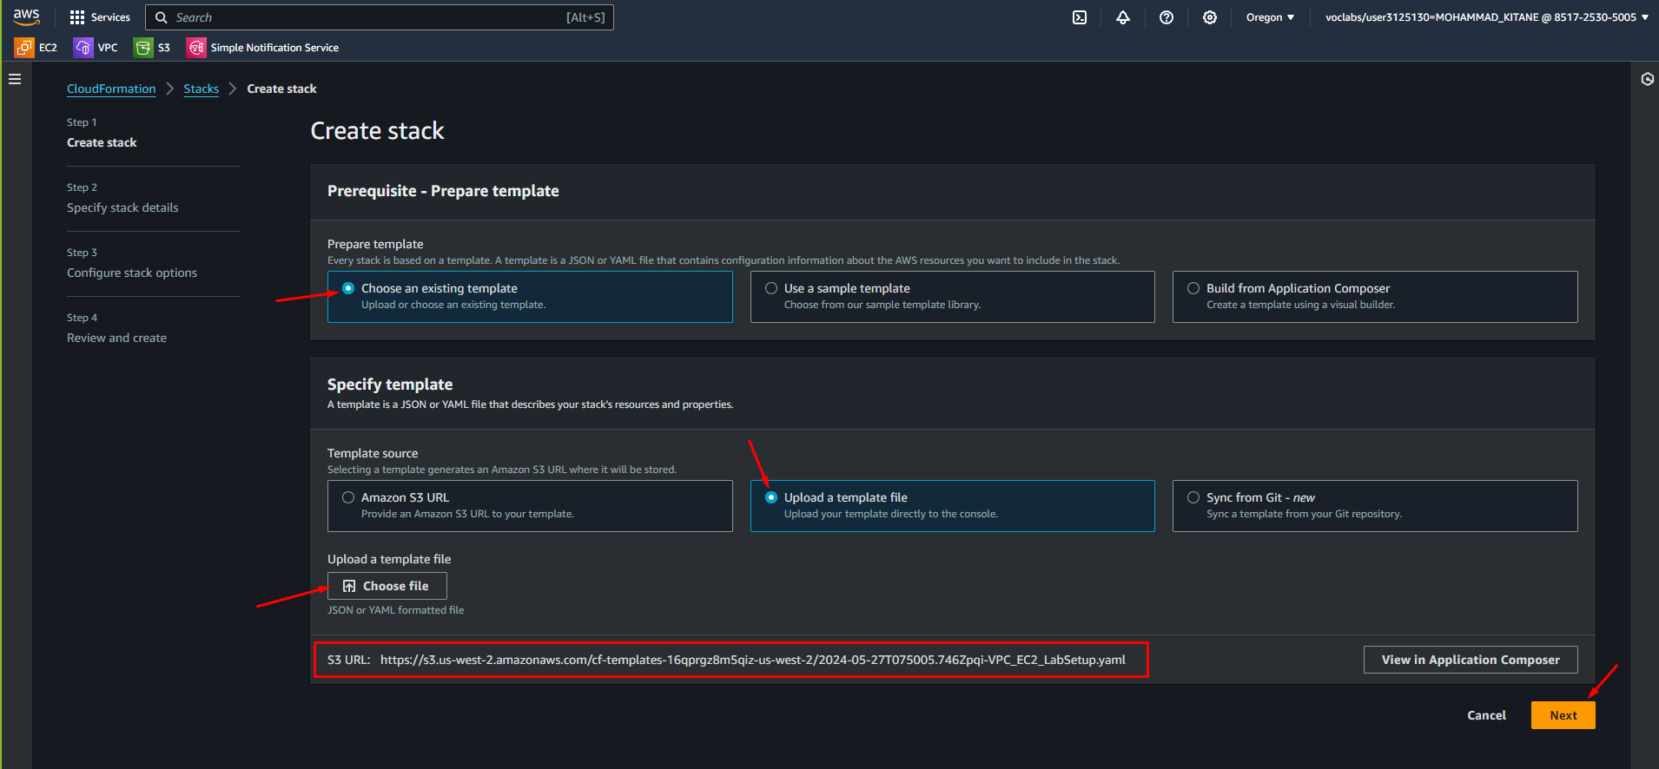

**Step 4:**

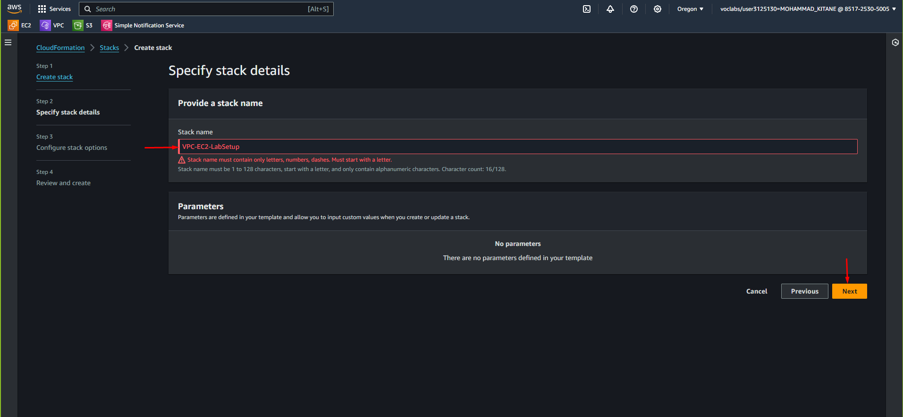

**Step 5:**

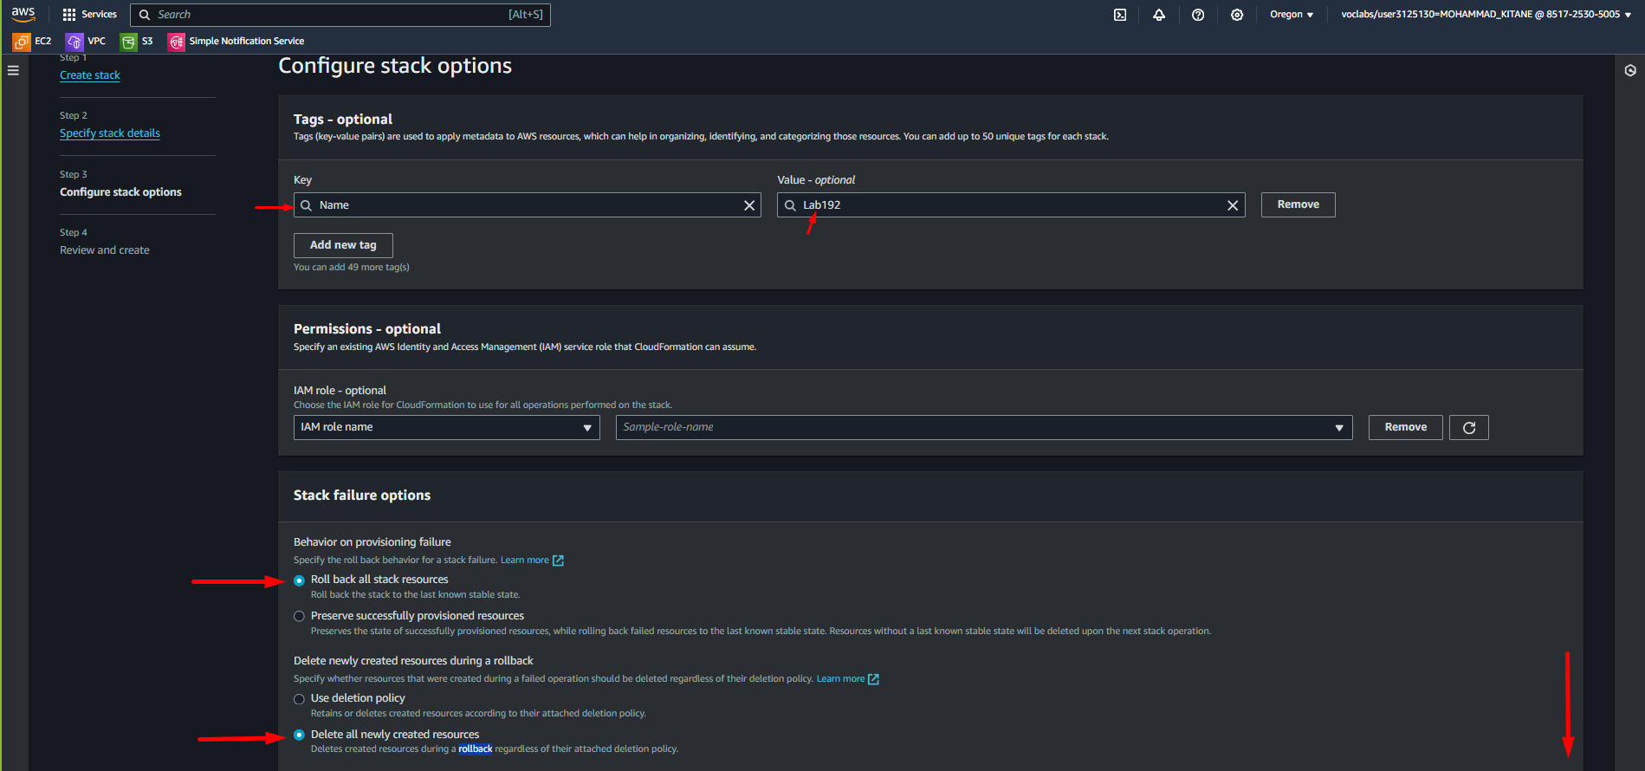

**Step 6:**

**Step 7:**

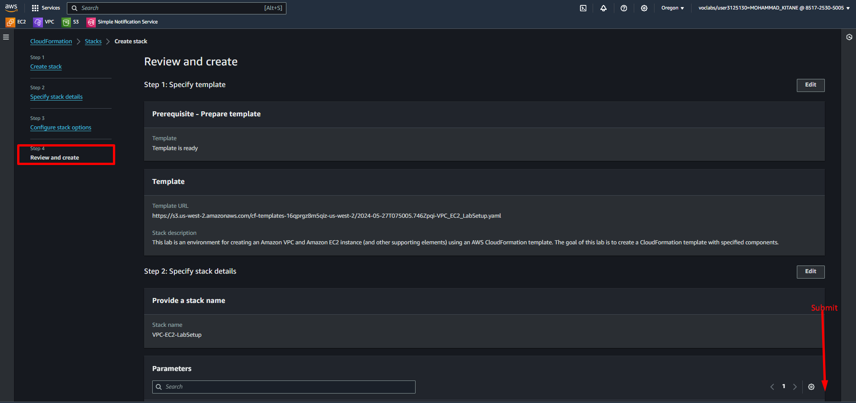

**Step 8:**

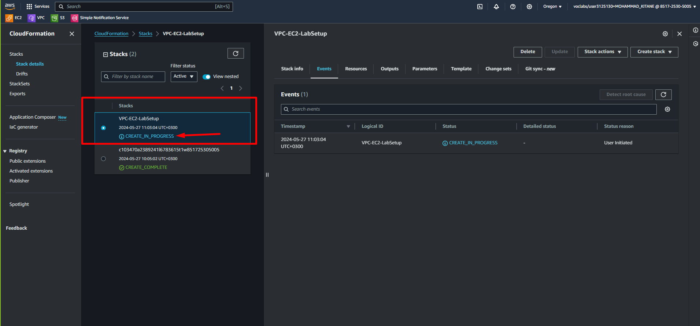

**Step 9:**

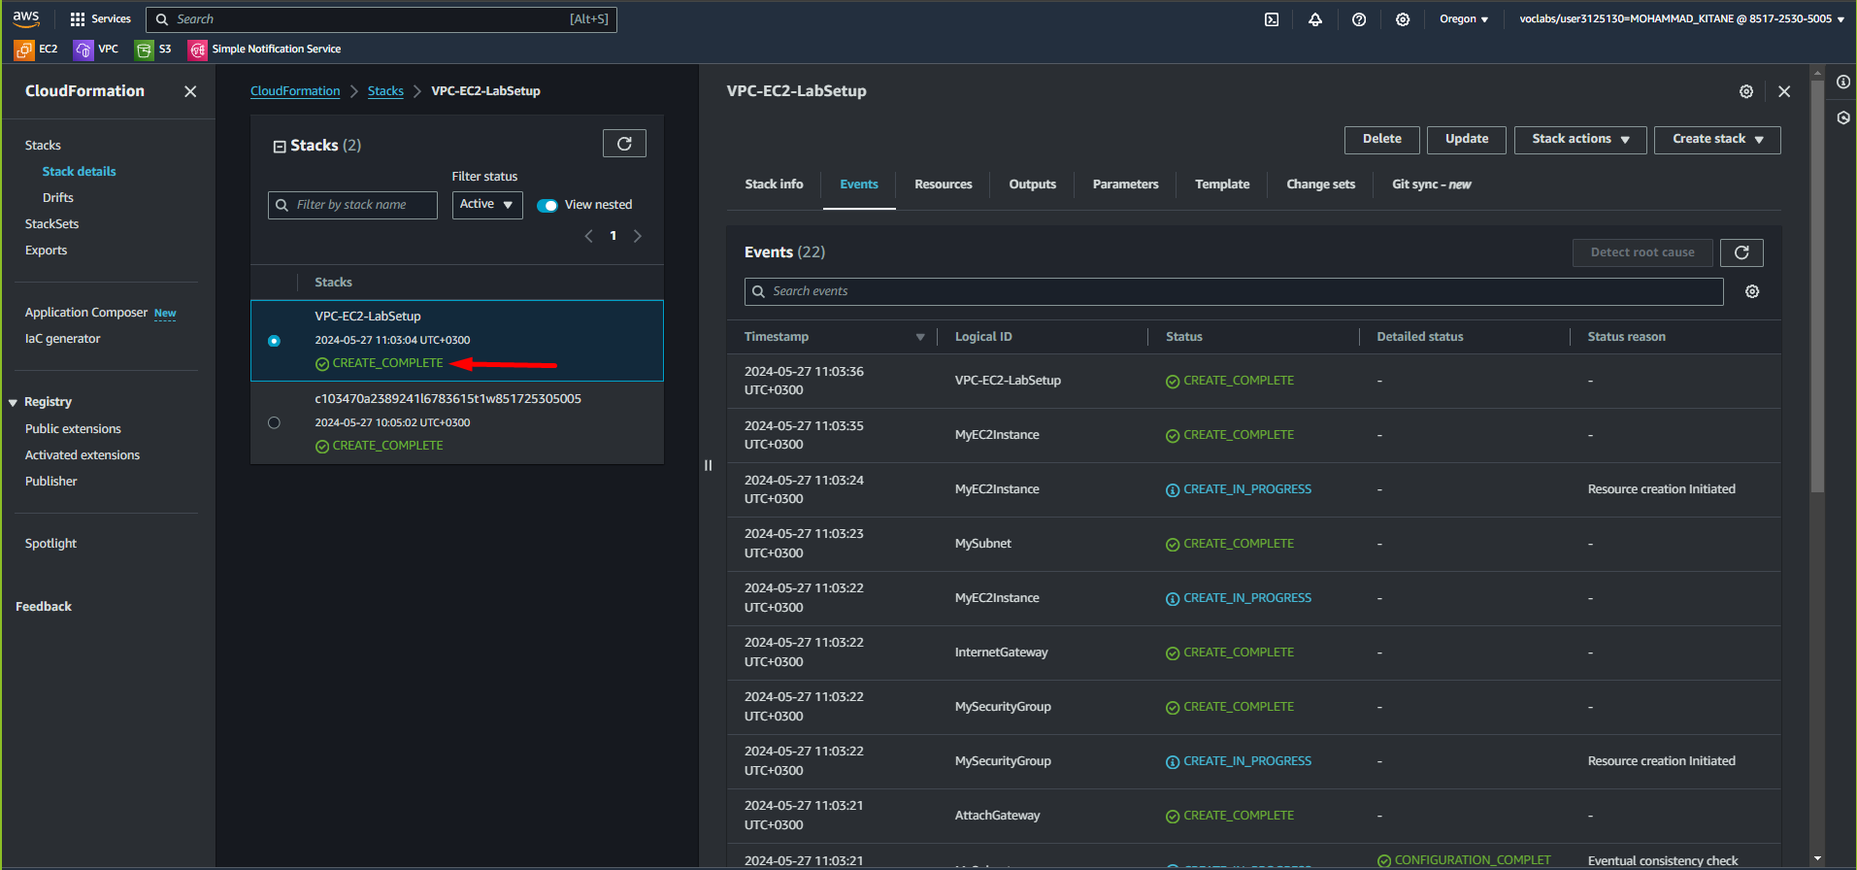

**Step 10:**

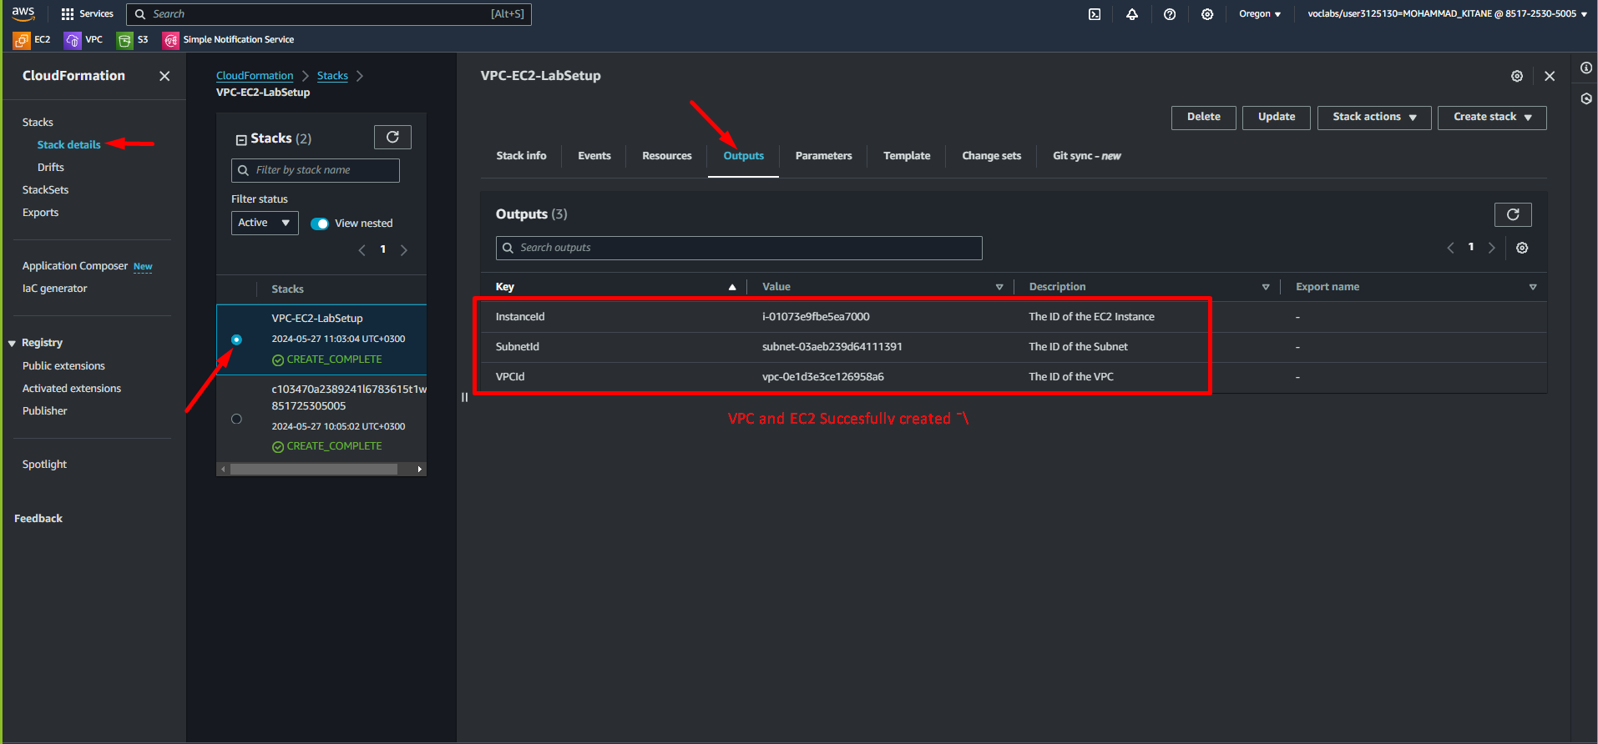

**Step 11:**

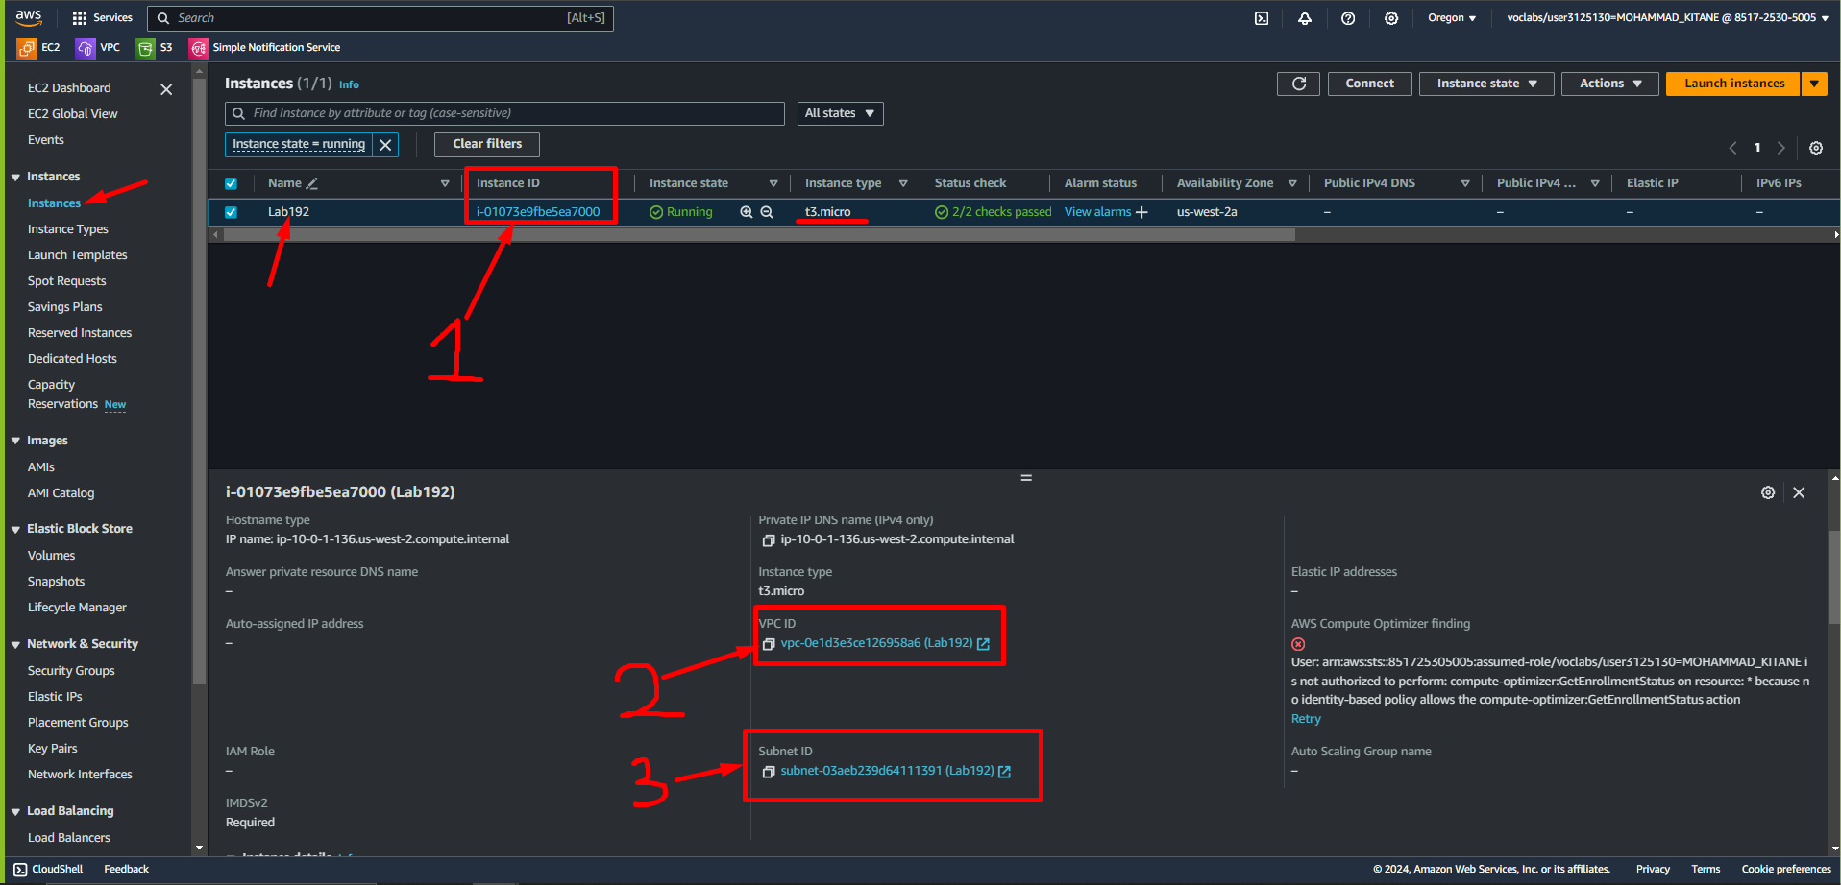

**Step 12:**

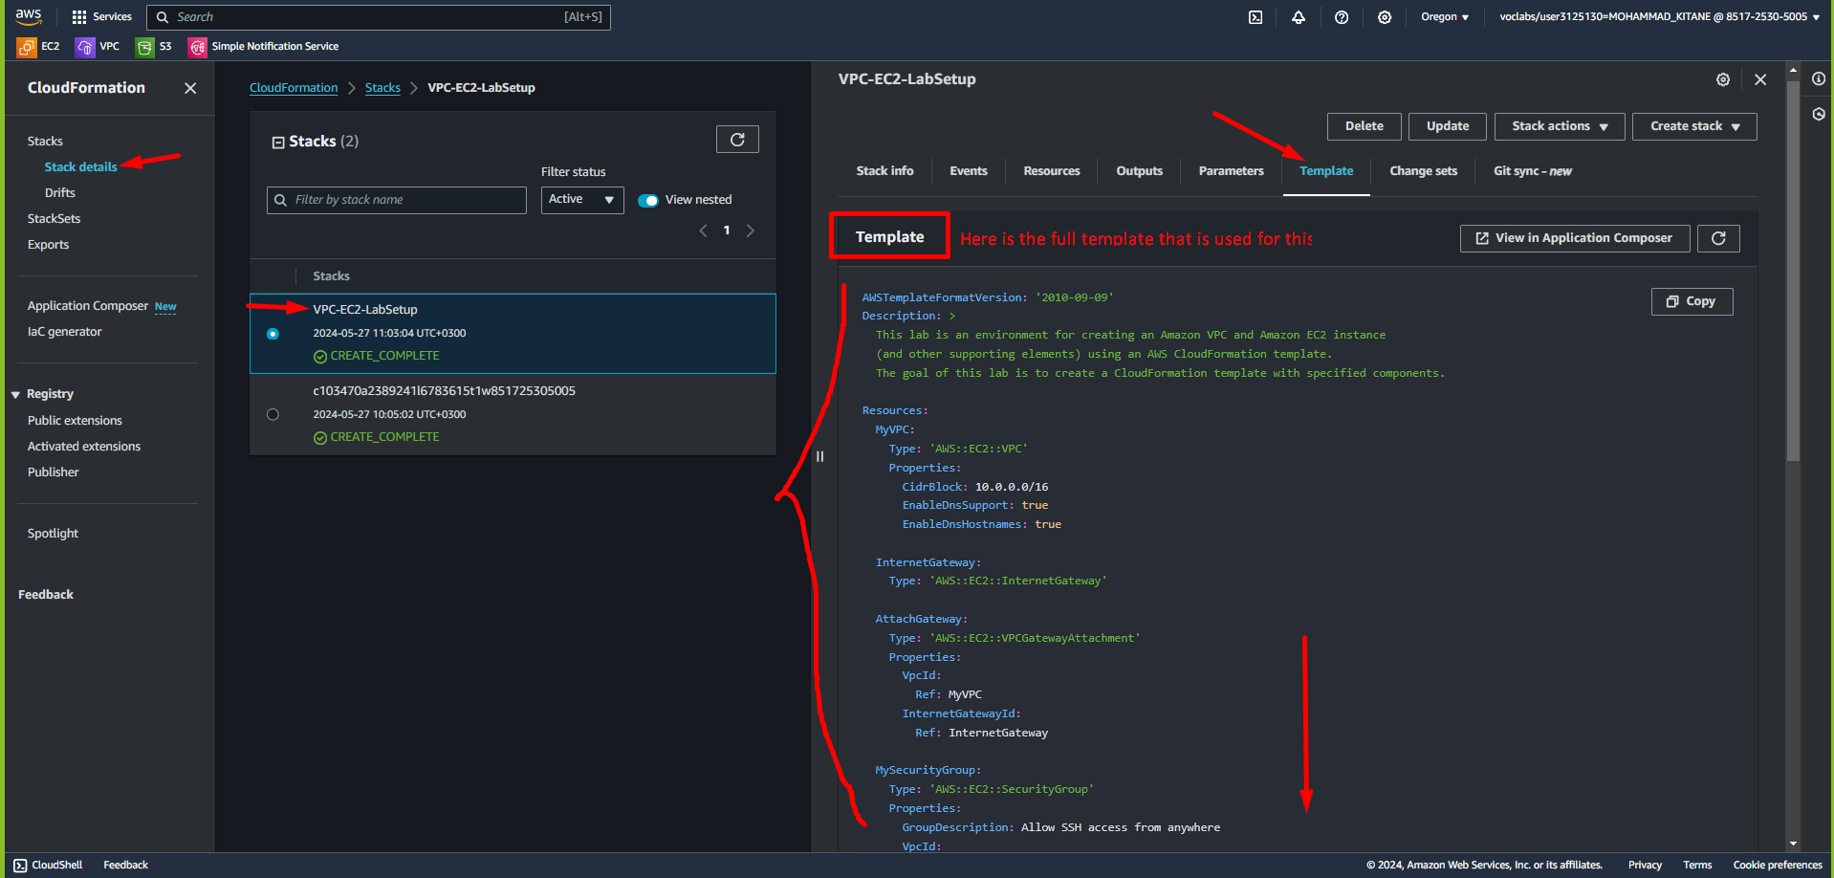

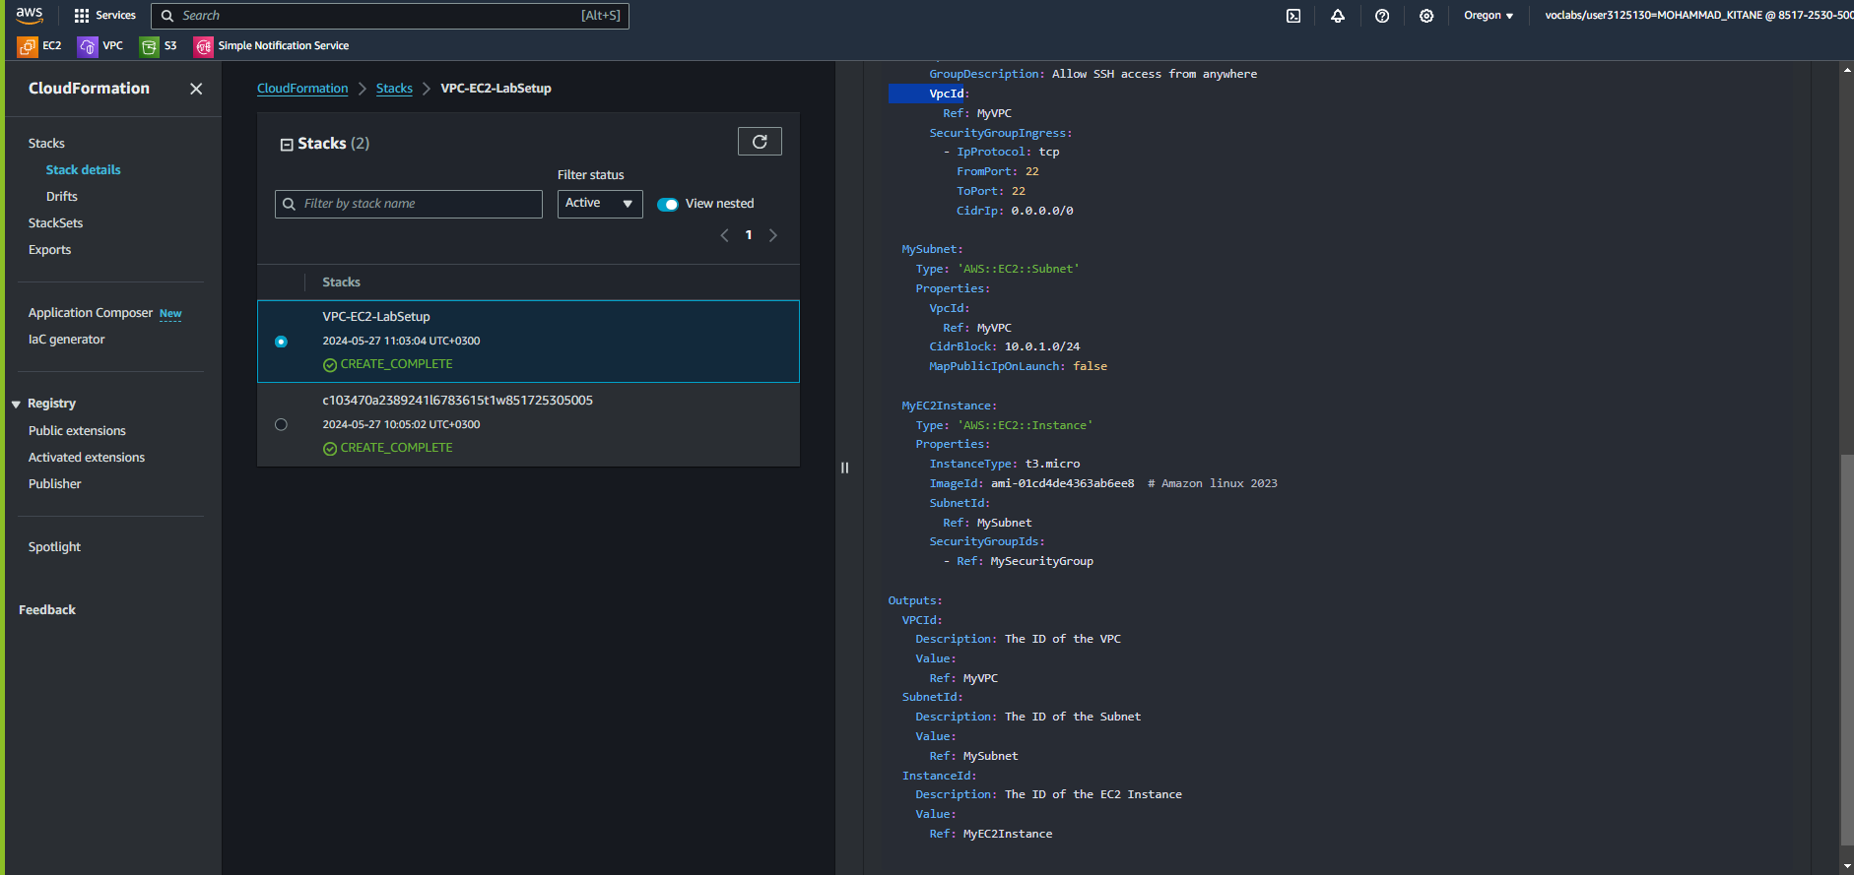

**Step 13:**

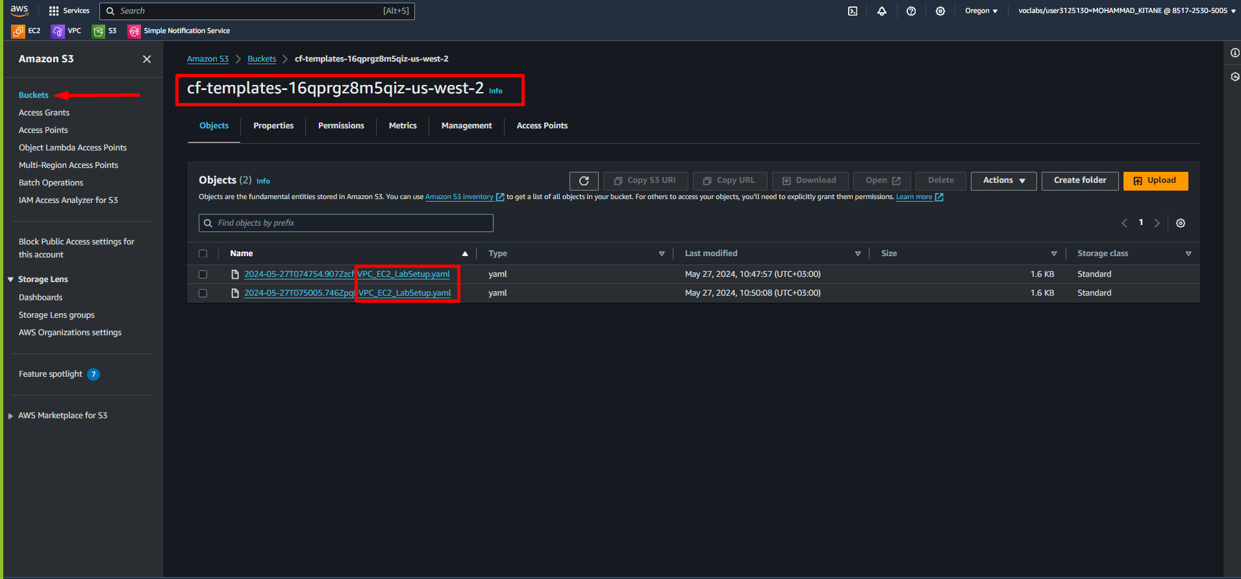

**Final Diagram:**

